**Assignment 1**

1. Report View

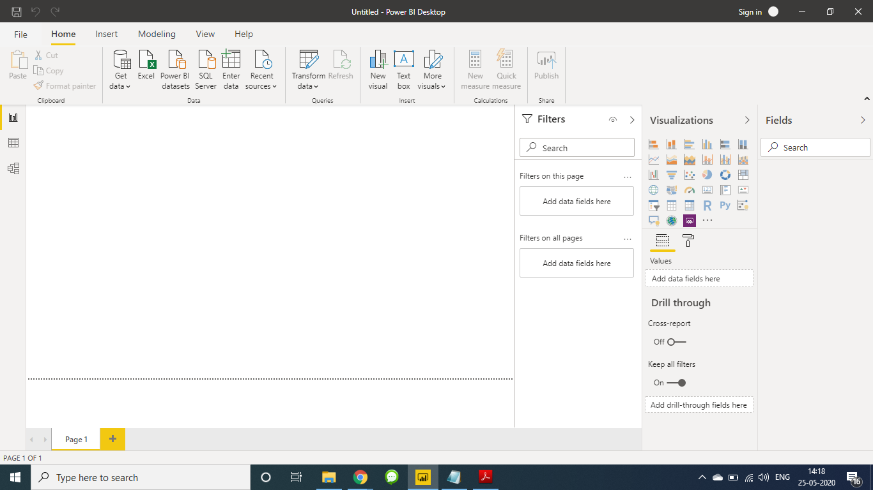

1. Data View

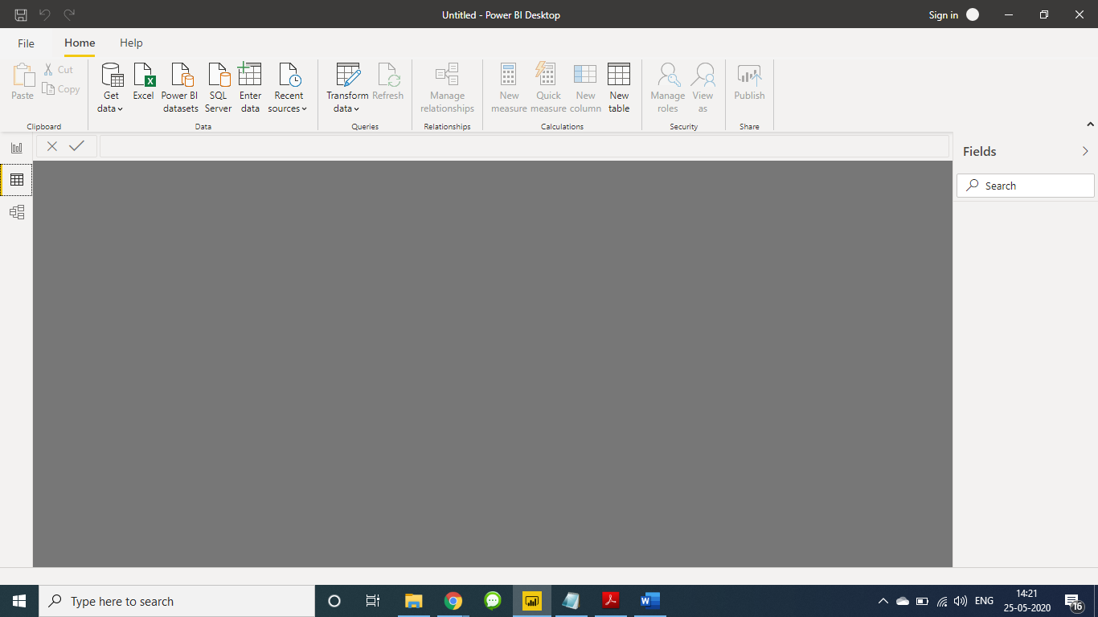

1. Model view

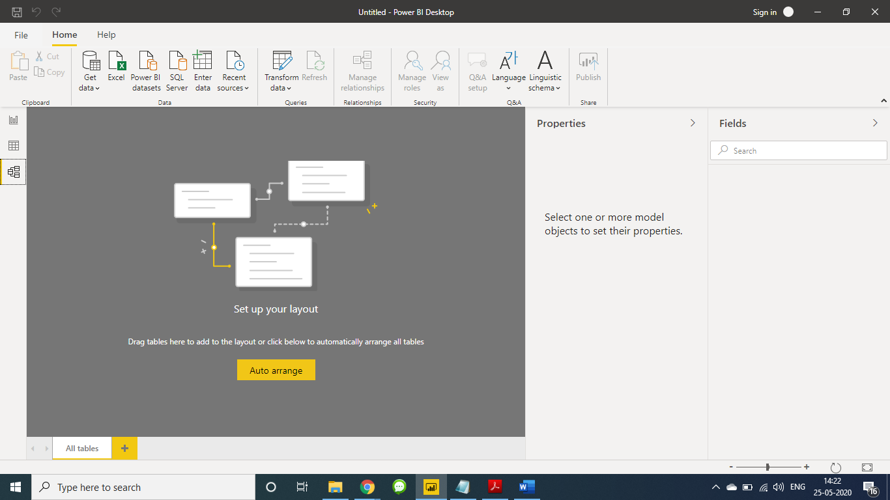

1. Power Query Editor View

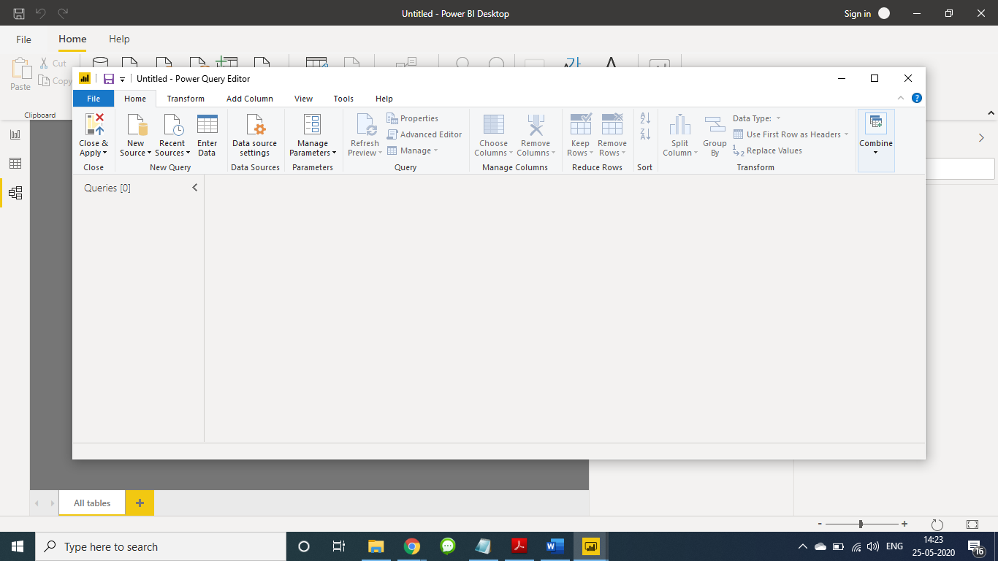

5. Advance Editor View

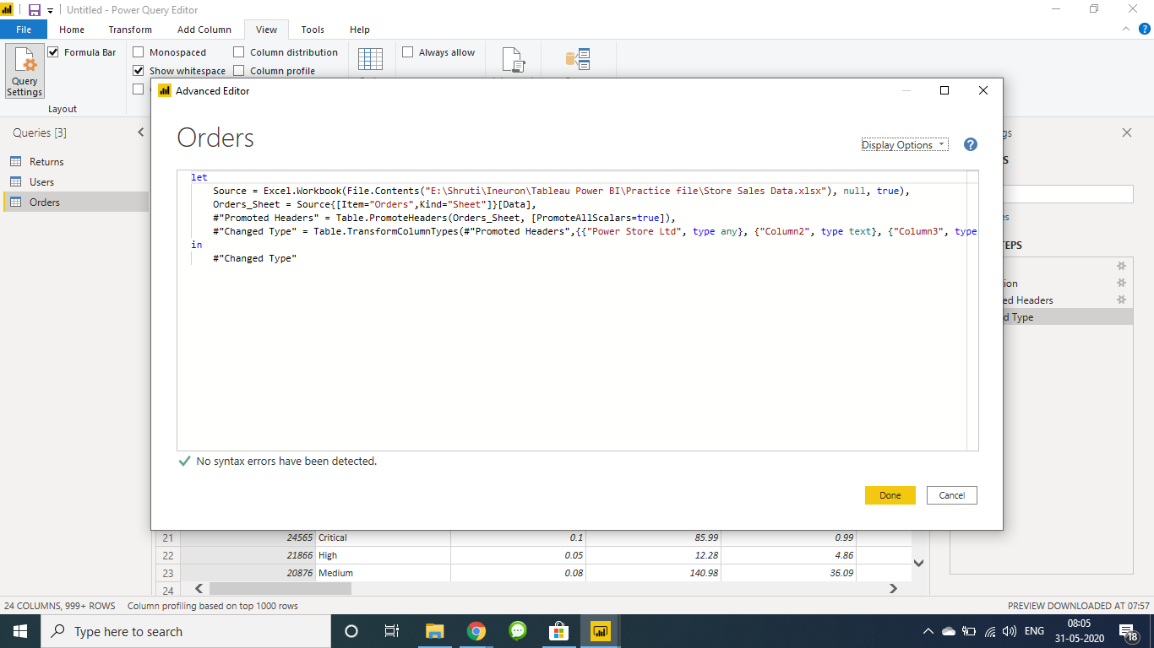

Details of Power BI products with price

1. Power BI Desktop

Content creation - the Power BI Desktop tool is used to author reports and prepare, model, and create data visualizations.

Price - Free

1. Power BI Pro

Content publication – It is used to collaborate with colleagues, model data, author content, share dashboards, publish reports, and perform ad-hoc analysis with a Power BI Pro license.

Price – Rs. 660 per month

1. Power BI Premium

Content consumption - Read and interact with pre-published dashboards and reports with either a per-user Power BI Pro license or a Power BI Premium license for large-scale databases.

Features are as follow:

* Enterprise BI, big data analytics, cloud and on-premises reporting
* Advanced administration and deployment controls
* Dedicated cloud compute and storage resources
* Allows any user to consume Power BI content

Price – Rs. 330,190 (Monthly price per dedicated cloud compute and storage resource with annual subscription)